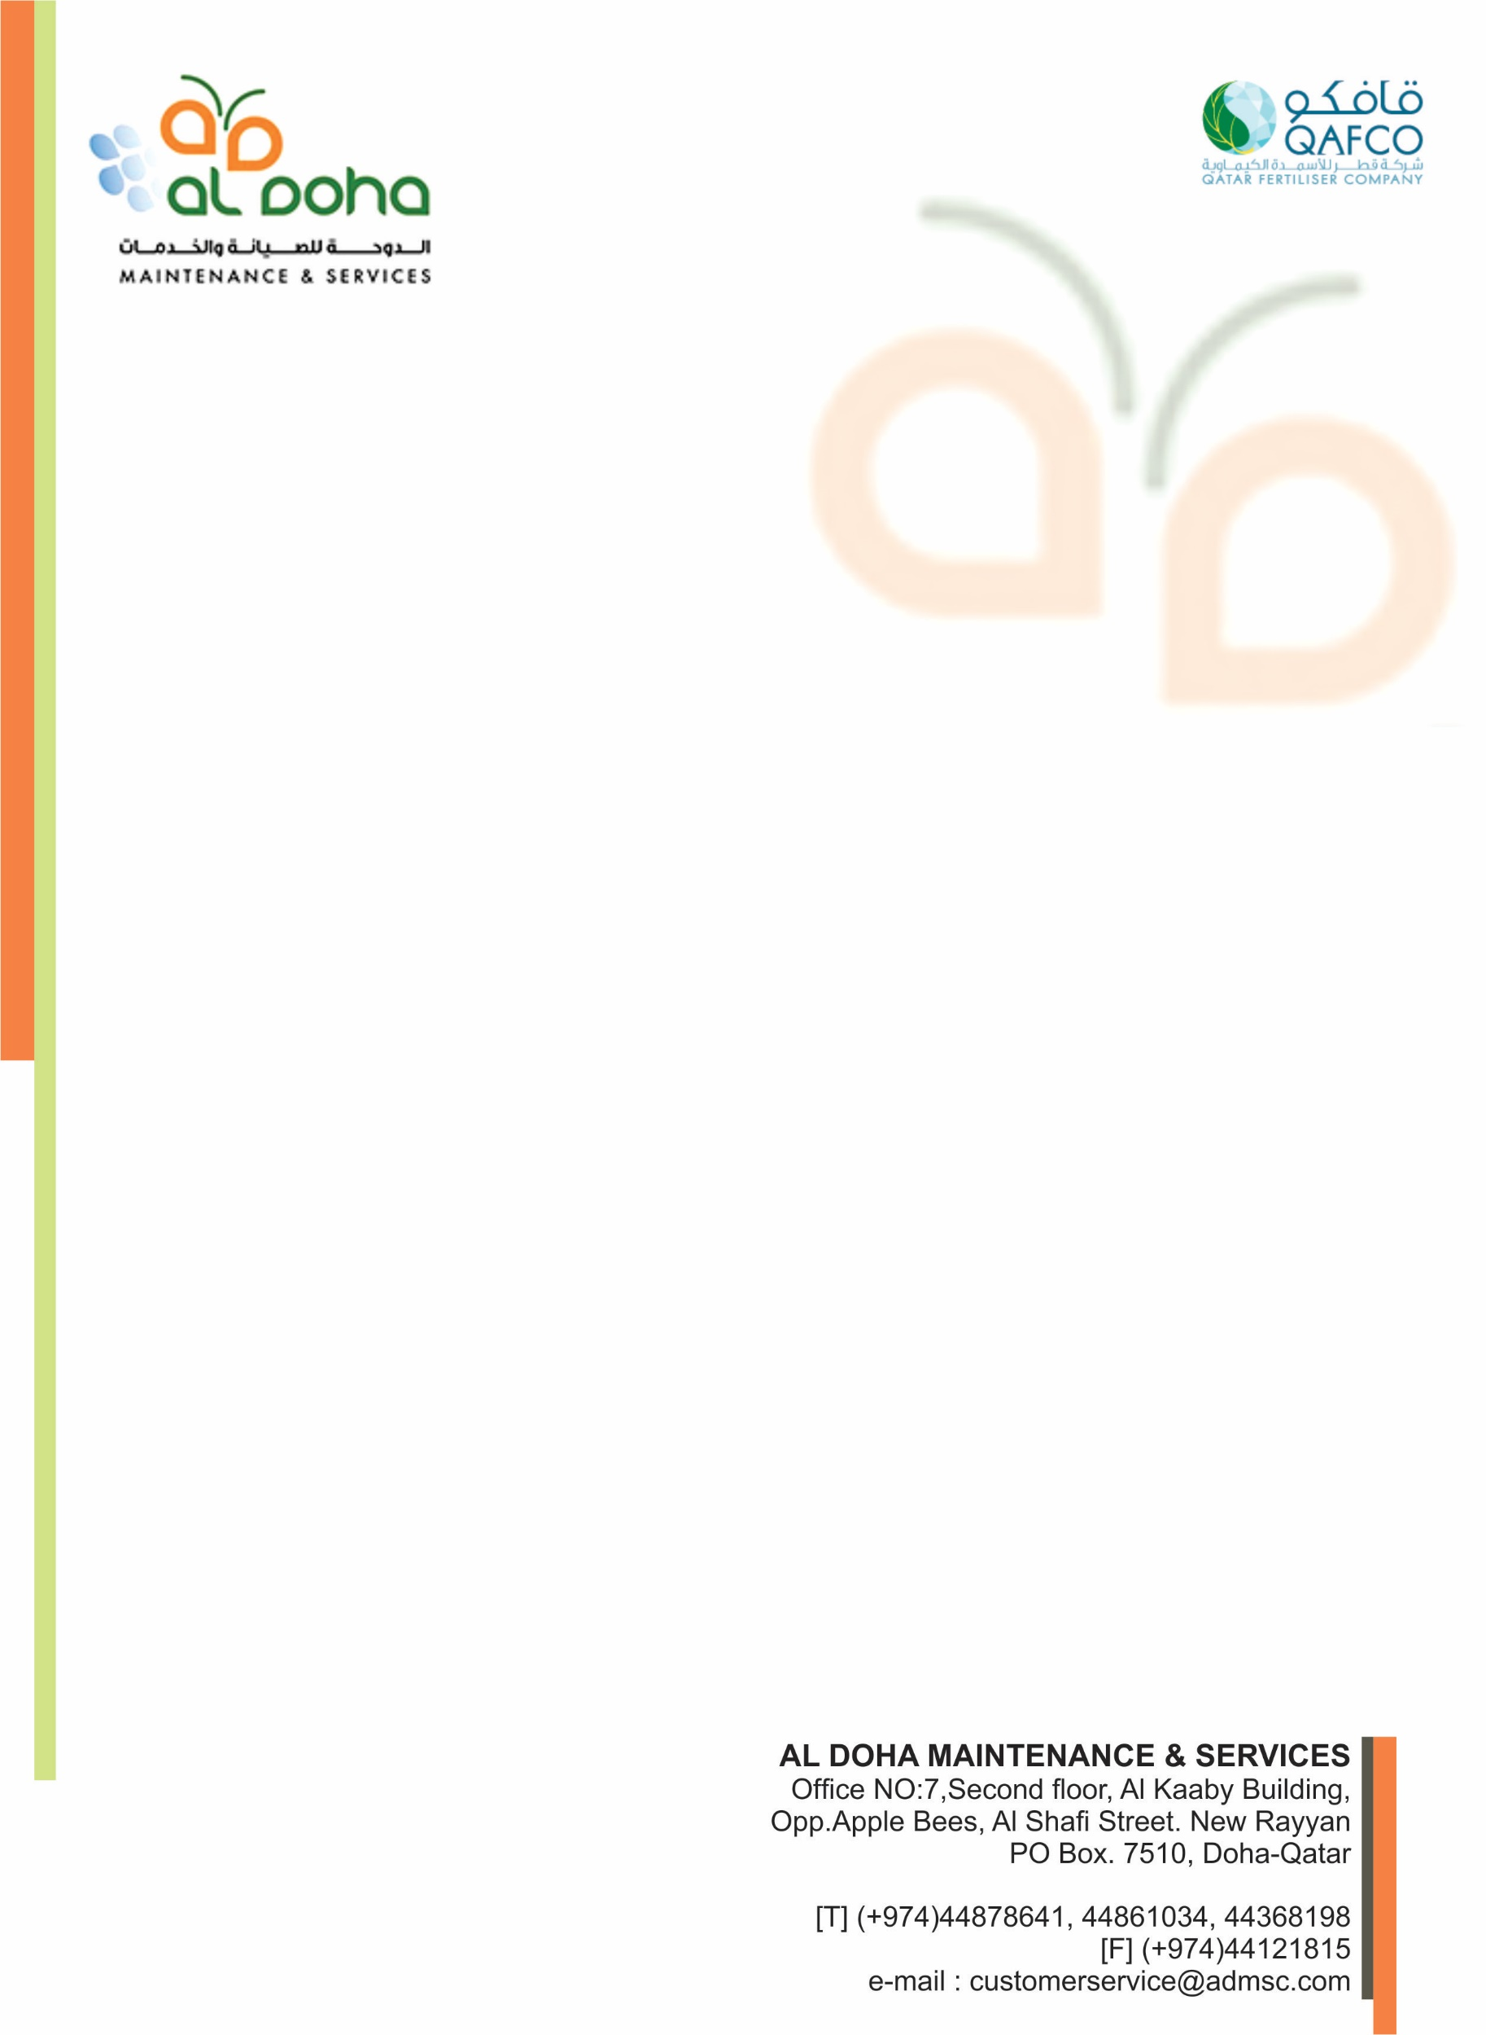

**TO WHOM IT MAY CONCERN**

This is certified that Mr. <Name> <fname> Passport No. <Passport> has employed by Al-Doha Maintenance & Services at Qatar Fertiliser Company Project from <From2> to <To2> as <Designation>.

This certificate is issued to him as the Company’s way of expressing recognition and appreciation for this exceptional performance on carrying out his assigned duties and responsibilities. The Company is extending to him the best wishes for the future.

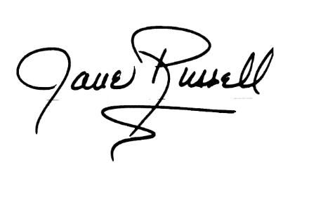

DAVID RUSSELL

Project Manager